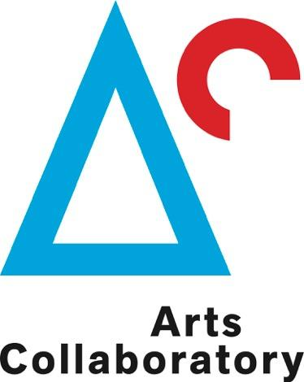

Application: Residency opportunity in Colombia for artists, curators, or researchers, related to Arts Collaboratory participants

**Deadline for summary proposal**

**31st July 2017**

## **I. APPLICANT**

|  |
| --- |
| **ARTSCOLLABORATORY** Mail your application form to:  **call@artscollaboratory.org** |

**This form is your application to Arts Collaboratory. Please keep it short and to the point, we ask you to limit your answers to a maximum of six A4 pages.**

**1. Basic info.**

|  |  |
| --- | --- |
| **Name and Surname:** |  |
| **Date of birth:** |  |
| **Correspondence address:** |  |
| **Postcode:** |  |
| **Country of residency:** |  |
| **Telephone number:** |  |
| **Email address:** |  |
| **Website: (if applicable)** |  |
| **I wish to apply for the residency with: (see** [**http://artscollaboratory.org/participants/**](http://artscollaboratory.org/participants/) **)  note: you can apply up to 2 organizations in Colombia** |  |
| **Proposed period of stay:**  **note: 6-8 week residencies to take place between 1st February and 30th June 2018** |  |
| **How did you hear about this residency call?** |  |

## **II. THE RESIDENCY**

**1. Motivation Statement (up to 1000 words)**

*Describe the motivation/background for your stay at the specific residency. Describe the specific project you wish to develop or the starting points/ideas for working at the residency*

**2. What will you need from the organization(s) to achieve this? (up to 200 words)**

*Local arts scene, wider communities, locations, translation, assistant, materials, etc.*

**3. Describe your tentative list of activities before, during and after your residency (up to 300 words).**

*Previous research and contacts, project execution, presentation and knowledge sharing in the home country*

**4. Links of previous works**

**5. Portfolio (15 images maximum) and C.V.**

*Please attach this documents in PDF files up to 10 megas send it to* [*call@artscollaboratory.org*](mailto:call@artscollaboratory.org) *with the subject “Residency proposal”)*

**6. Other**

*Do you have any other additional remarks?*